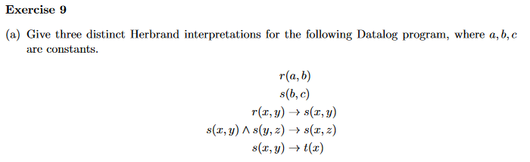

I1 = { r(c, c) }

I2 = { r(b, b), r(a, a), s(b,c) }

I3 = { s(a, b) }

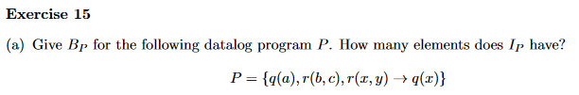

#constants#variables

32=9